ROC / Taiwan Visa Services For Philippine Passport Holders
Filipinos, who intend to travel to the ROC(Taiwan), can now choose to apply their respective visas through any of these 4 options below:
 | OPTION Visa-Free Certificate | OPTION eVisa | OPTIONAppropriate visa stamped in passport
Eligibility | Those who possess at least one of the following documents issued by ROC(Taiwan), Australia, Canada, Japan, South Korea, New Zealand, any of the Schengen-member, the United Kingdom, or the United States: a valid resident or permanent resident card, a valid entry visa (electronic visas included), or a resident card or visa that has expired less than 10 years prior to the date of arrival in Taiwan. | A short visit less than 30 days for tourism and business purpose, as well as for visiting relatives and attending international conferences or sport events in Taiwan. | Filipinos who intend to visit Taiwan for the purposes of transit, tourism, family visit, international conference participation, study, employment, business, missionary work or other activities as approved by the ROC authorities, may apply for appropriate visas at any of the ROC overseas missions.
Application Website | https://niaspeedy.immigration.gov.tw/nia_southeast | https://visawebapp.boca.gov.tw  (Choose eVisa Applications) | https://visawebapp.boca.gov.tw  (Choose General Visa Applications)
Fee | Free of charge | An eVisa is NT$1,600. Including the NT$32 processing fee for the online credit card payment. The total amount is NT$1,632. | Visitor Visa : Php.2,400, 3 Working Days  Expedite Processing: Php.3,600, 1 Working Day Resident Visa : Php.3,100, 4 Working Days  Expedite Processing : Php.4,650, 2 Working Days
Processing | Processing takes around 5-10 minutes. | Processing takes 3 working days excepting pending cases, and there is no expedite processing. | Filing Time : Monday to Friday (8:45am to 11:45am)  Releasing Time : Monday to Friday (1: 45pm to 4:30pm)
Required documents | The original document of the aforementioned resident cards or visas | No need for proof of occupation and supporting financial documents | For detailed information about different types of ROC visas, you may check our website: http://www.roc-taiwan.org/ph_en
 | OPTION Visa-Free Certificate | OPTION eVisa | OPTIONAppropriate visa stamped in passport
How to apply | ►STEP1: Fill out an online application  ►STEP2: Await confirmation  ►STEP3: Print out the “Travel Authorization Certificate” | ►STEP1: Fill out an online application  ►STEP2: Pay the eVisa fee by credit card  NOTE: Online processing fee will not be refunded under any circumstance. Please double check your application before proceeding to payment.  ►STEP3: Await confirmation  ►STEP4: Receive confirmation by email  ►STEP5: Print out the eVisa | ►STEP1: Fill out an online application form, and then print out the form affix signature on the last page  ►STEP2: Submit the application form along with visa fee and other required documents to our consular counters  ►STEP3: Claim your passport with visa
Validity of Certificate /Visa | An approved “Travel Authorization Certificate” is valid for 90 days, multiple entries within these 90 days are allowed. | An eVisa is valid for 3 months from the issue date, single-entry only. | The validity of the visa, the number of entries shall be determined by the applicant’s purpose of visit.
Duration of stay in Taiwan | 30 days ( starting from the day after arrival) | 30 days( starting from the day after arrival) | The duration of stay for a visitor-visa holder shall be determined by the applicant’s purpose of visit.
Sample of certificate/visa | 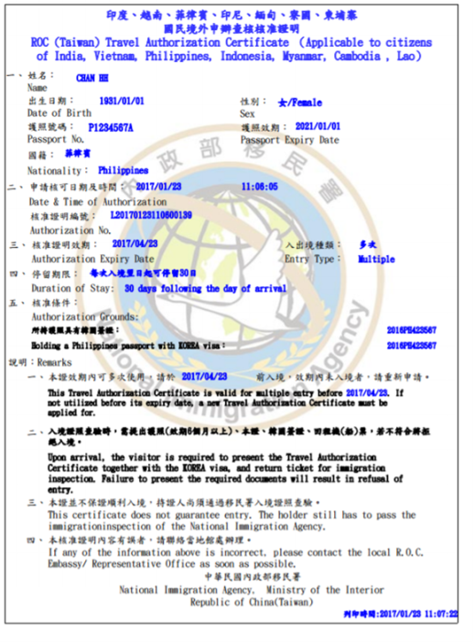 | 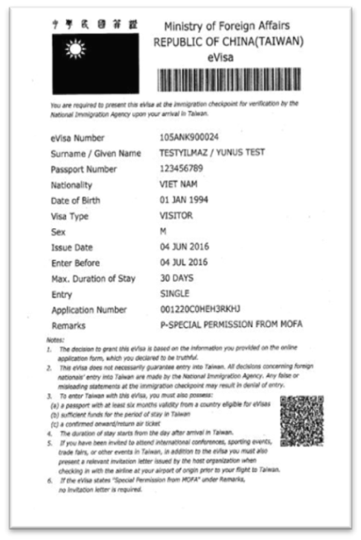 | 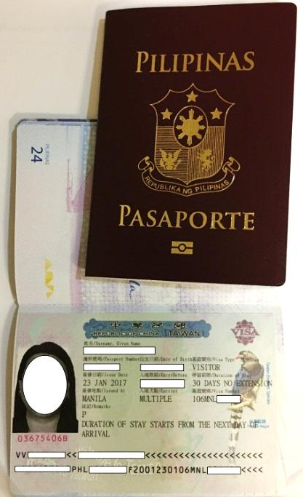
 | OPTION Project for Simplifying Visa Regulations for High-end Group Tourists
Eligibility | Tourist groups organized by the designated travel agencies and corporate incentive groups from the Philippines, are qualified to apply for an entry visa to the R.O.C (Taiwan) with no need for proof of occupation and supporting financial documents. For further information, please visit the Taiwan Tourism Bureau website: http://admin.tbroc.gov.tw/news/news_d_en.aspx?no=31&d=6079&tag=1
Fee | Free of charge
Processing | Visa processing takes 3 working days
How to apply | ►STEP1: Authorize any of the designated travel agencies to handle application matters and send the application forms to our Kuala Lumpur office, Taiwan Tourism Bureau (Taiwan Visitors Association). The processing will take 7 to 11 days, depending on the number of group members.  ►STEP2: Once the application is approved, the travel agency can submit the eVisa applications for all group members.  ►STEP3: Await confirmation  ►STEP4: Receive confirmation by email  ►STEP5: Print out the eVisa
Validity of Visa | An eVisa is valid for 3 months from the issue date, single-entry only.
Duration of stay in Taiwan | 30 days (starting from the day after arrival)  Note: The high-end tourist group should enter and depart Taiwan as a group.

