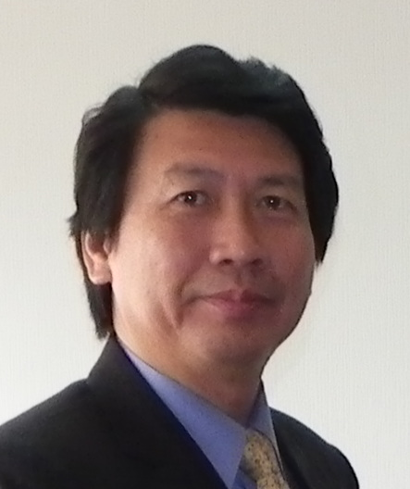

Ambassador Joey Chung I Wang

Representative, Taipei Economic and Cultural Office in Czech Republic

Educational Background (學歷)
National Taiwan Ocean University, BS 1976
國立海洋大學畢業
Visiting Scholar, Faculty of Law, Jesus College, University of Cambridge, UK 1994
英國劍橋大學法學院訪問學人
Research Fellow, Center for International Documentation on organized and Economic Crime, UK 1994-1996
英國國際組織及經濟犯罪研究中心研究員
National Executive Institute, FBI, USA, 2013
美國聯邦調查局國家行政管理學院結業

Experience(經歷)
Legal Attache, Taipei Economic and Cultural Representative Office in USA
駐美國代表處法務秘書
Chief and Senior Specialist of Economic Crime Prevention Center, Investigation Bureau, Ministry of Justice, Taiwan ROC
法務部調查局經濟犯罪防制中心科長、專門委員
Legal Attache, Embassy of ROC in Republic of South Africa
中華民國駐南非大使館法務秘書
Director, Anti-Money Laundering Division, Investigation Bureau, Ministry of Justice
法務部調查局洗錢防制處處長
Director, Department of International Affairs, Investigation Bureau, Ministry of Justice
法務部調查局國際事務處處長
Director General, Investigation Bureau, Ministry of Justice
法務部調查局局長

