台灣駕照英譯解釋

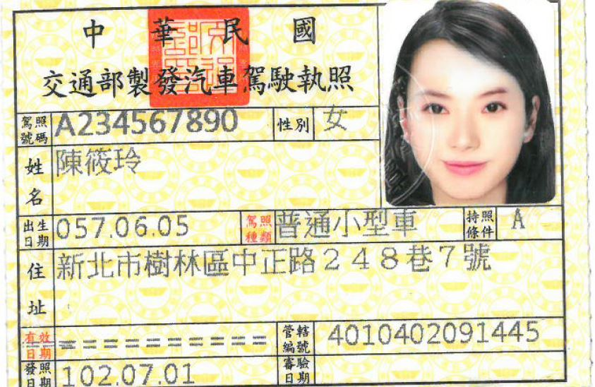
- Name of the Holder: 參考護照外文，Last name 必須全大寫，例如YANG, Yi-Jing
- Gender: Male/ Female
- License No.: 身分證字號 A234567890
- Date of Birth: June 5, 1968
- License Class:[Class B (Passenger Motor Vehicle)汽車/Class A2 (Heavy Motorcycle) 機車]
- Restrictions: None
- Address: 請參考中華郵政地址英譯，切誤自己亂翻
https://www.post.gov.tw/post/internet/Postal/index.jsp?ID=207
- Control Number: 4010402091445
- Date of Issue: July 1, 2013
- Expiration: None

此為範本，請翻至下一頁填寫個人駕照資訊

汽車駕照翻譯

This is to certify that Mr. XXX, XXXX holds a valid driver’s license of the Republic of China (Taiwan). The information listed on the license is as follows:

Name of the Holder: XXXX, Xxx-Xxx (Last name, First name)
Gender: Male/Female
License No.: A123456789
Date of Birth: March 19, 1987
License Class: Class B (Passenger Motor Vehicle)
Restrictions: None
Address: No.66, Guandu Rd., Beitou Dist., Taipei City, Taiwan(駕照正面的地址)
Control Number: 2110703211548
Date of Issue: March 19, 2007
Expiration: None
*請參考範本，將您駕照上的資料輸入至上列黃色區域。並請在填寫完成後寄至bostonvisa@mofa.gov.tw，主旨Subject為申請人護照上之英文姓名及性別(m/f)，例如: 葉大雄，YEH, Da-Xiong_m; 楊宜靜，YANG, Yi-Jing_f
* XXXX, Xxx-Xxx (Last name, First name), 姓名格式請完全遵照護照上之外文名字
*中華郵政地址英譯: https://www.post.gov.tw/post/internet/Postal/index.jsp?ID=207
*資料有誤者，經通知且修正後始得繼續辦理申請件，一般駕照換照文件證明約需20工作天，資料錯誤未即時補件者不在此限。

機車駕照翻譯

This is to certify that Mr. XXXX, Xxx-Xxx holds a valid driver’s license of the Republic of China (Taiwan). The information listed on the license is as follows:

Name of the Holder: XXXX, Xxx-Xxx
Gender: Male/Female
License No.: A123456789
Date of Birth: March 19, 1987
License Class: Class A2 (Heavy Motorcycle)
Restrictions: None
Address: 5F., No.66, Guandu Rd., Beitou Dist., Taipei City, Taiwan
Control Number: 2110703211548
Date of Issue: March 19, 2007
Expiration: None

*請參考範本，將您駕照上的資料輸入至上列黃色區域。並請在填寫完成後寄至bostonvisa@mofa.gov.tw，主旨Subject為申請人護照上之英文姓名及性別(m/f)，例如: 葉大雄，YEH, Da-Xiong_m; 楊宜靜，YANG, Yi-Jing_f
* XXXX, Xxx-Xxx (Last name, First name), 姓名格式請完全遵照護照上之外文名字
*中華郵政地址英譯: https://www.post.gov.tw/post/internet/Postal/index.jsp?ID=207
*資料有誤者，經通知且修正後始得繼續辦理申請件，一般駕照換照文件證明約需20工作天，資料錯誤未即時補件者不在此限。

